**实验4数据流**

实验相关材料位于：<ftp://192.168.40.100/>下的“**--- 梁其洋**”目录下（可以通过搜索名字找到）

作业提交到：[ftp://192.168.40.14/梁其洋/网络编程**班/实验*](ftp://192.168.40.14/梁其洋/网络编程**班/实验*)

要求：

1. 提交时**将本文档重新命名**，文档命名规则：学号+姓名+实验*，例如，**517300614400 张三 实验*.docx （一定要学号在前姓名在后，方便自动排序！）**

2. 你们没有FTP文件的删除权限，**如果需要提交新版本，在姓名后加序号后提交即可，例如，517300614400张三（1）实验*.docx**

**4.1** **数据编码和解码**

**实验目的：**

掌握用Encoding类进行编码和解码

**实验步骤：**

（1）新建一个名为ch4的WPF工程， 在mainWindow.xaml的<grid>标签中添加一个TextBlock控件。

<Grid>

<TextBlock Name="textBlock1" />

</Grid>

（2）在mainWindow.xaml.cs文件的mainWindow方法中添加以下方法

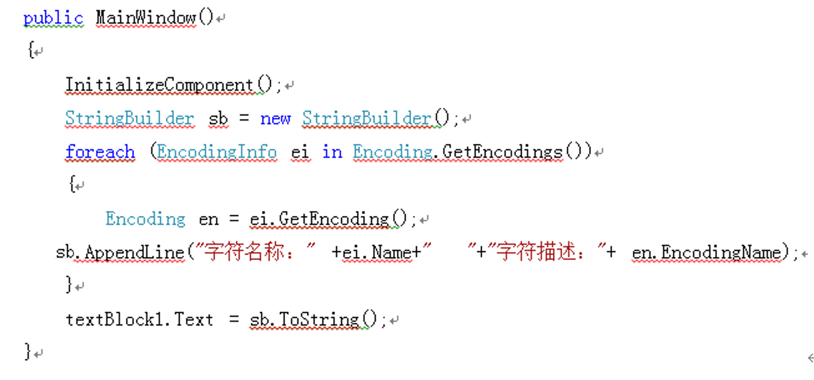

程序截图：

using System;

using System.Collections.Generic;

using System.Linq;

using System.Text;

using System.Threading.Tasks;

using System.Windows;

using System.Windows.Controls;

using System.Windows.Data;

using System.Windows.Documents;

using System.Windows.Input;

using System.Windows.Media;

using System.Windows.Media.Imaging;

using System.Windows.Navigation;

using System.Windows.Shapes;

namespace sy4

{

/// <summary>

/// Interaction logic for MainWindow.xaml

/// </summary>

public partial class MainWindow : Window

{

public MainWindow()

{

InitializeComponent();

StringBuilder sb = new StringBuilder();

foreach (EncodingInfo encodingInfo in Encoding.GetEncodings())

{

Encoding en = encodingInfo.GetEncoding();

sb.AppendLine("字符名称：" + encodingInfo.Name + " 字符描述：" + en.EncodingName);

}

TextBox1.Text = sb.ToString();

}

}

}

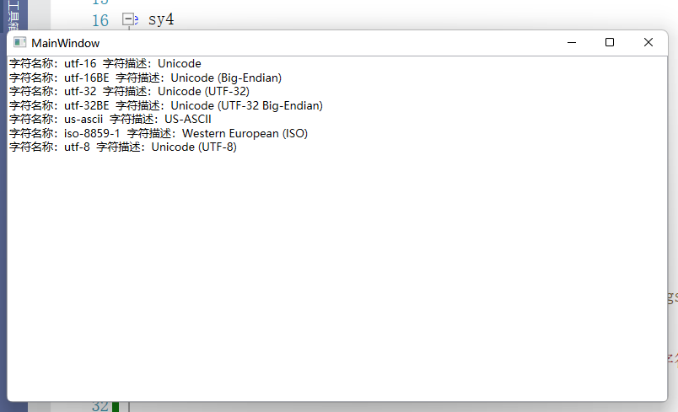

**4.2** **数据编码和解码**

**实验目的：**

**（1）利用Encoding类实现字符串的编码和解码**

**（2）不同编码之间的转换**

**实验步骤：**

把字符串“hello中国”转换成ASCII编码。

（1）去掉mainWindow.xaml文件中的以下代码：

<Grid>

<TextBlock Name="textBlock1" />

</Grid>

（2）在mainWindow.xaml文件中添加以下代码：

<DockPanel>

<Border DockPanel.Dock="Top">

<TextBlock Text="编码转换"/>

</Border>

<Border DockPanel.Dock="Bottom" >

<StackPanel Orientation="Horizontal" HorizontalAlignment="Center">

<Button Name="btn1" Margin="10 6 10 6" Padding="10 0 10 0" Content="编码转换" Click="btn1_Click"/>

<Button Name="btn2" Margin="10 6 10 6" Padding="10 0 10 0" Content="编码解码" Click="btn2_Click"/>

</StackPanel>

</Border>

<ScrollViewer>

<StackPanel Background="White" TextBlock.LineHeight="20">

<TextBlock x:Name="textBlock1" Margin="0 10 0 0" TextWrapping="Wrap"/>

</StackPanel>

</ScrollViewer>

</DockPanel>

（3）添加按钮btn1的click事件的实现代码：

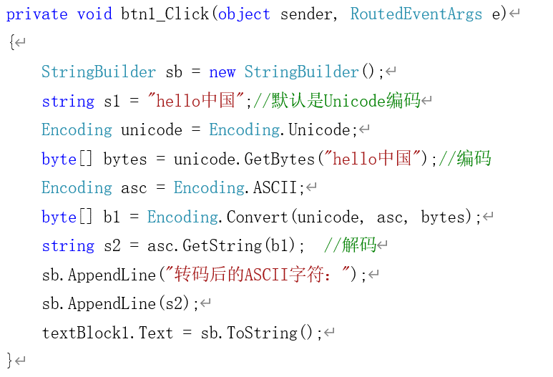

（4）添加按钮btn2的click事件的实现代码：

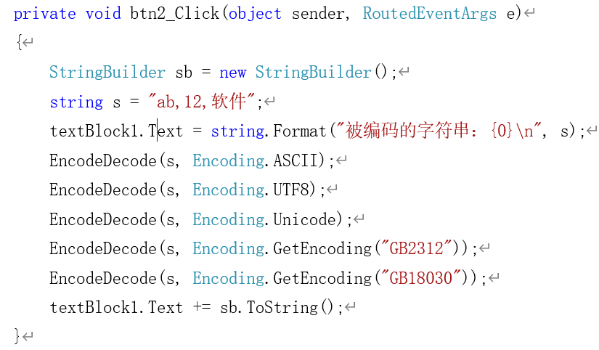辅助函数：

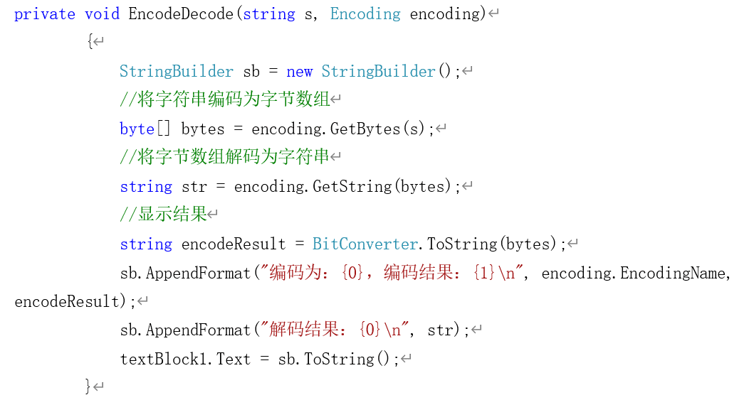

程序截图：

using System;

using System.Collections.Generic;

using System.Linq;

using System.Text;

using System.Threading.Tasks;

using System.Windows;

using System.Windows.Controls;

using System.Windows.Data;

using System.Windows.Documents;

using System.Windows.Input;

using System.Windows.Media;

using System.Windows.Media.Imaging;

using System.Windows.Navigation;

using System.Windows.Shapes;

namespace sy4_2

{

/// <summary>

/// Interaction logic for MainWindow.xaml

/// </summary>

public partial class MainWindow : Window

{

public MainWindow()

{

InitializeComponent();

}

private void btn1_Click(object sender, RoutedEventArgs e)

{

StringBuilder sb = new StringBuilder();

string s1 = "hello中国";

Encoding unicode = Encoding.Unicode;

byte[] bytes = unicode.GetBytes(s1);

Encoding asc = Encoding.ASCII;

byte[] b1 = Encoding.Convert(unicode,asc,bytes);

string s2 = asc.GetString(b1);

sb.AppendLine("转换后的ASCII字符");

sb.AppendLine(s2);

textBlock1.Text = sb.ToString();

}

private void btn2_Click(object sender, RoutedEventArgs e)

{

System.Text.Encoding.RegisterProvider(System.Text.CodePagesEncodingProvider.Instance);

StringBuilder sb = new StringBuilder();

string s = "ab,12,软件";

textBlock1.Text = string.Format("被编码的字符串：{0}\n", s);

EncodeDecode(s, Encoding.ASCII);

EncodeDecode(s, Encoding.UTF8);

EncodeDecode(s,Encoding.Unicode);

EncodeDecode(s,Encoding.GetEncoding("GB2312"));

EncodeDecode(s, Encoding.GetEncoding("GB18030"));

textBlock1.Text += sb.ToString();

}

StringBuilder sb = new StringBuilder();

private void EncodeDecode(string s, Encoding encoding)

{

byte[] bytes = encoding.GetBytes(s);

string str = encoding.GetString(bytes);

string encodeResult = BitConverter.ToString(bytes);

sb.AppendFormat("编码为：{0},编码结果为：{1}\n", encoding.EncodingName, encodeResult);

sb.AppendFormat("解码结果：{0}\n", str);

textBlock1.Text = sb.ToString();

}

}

}

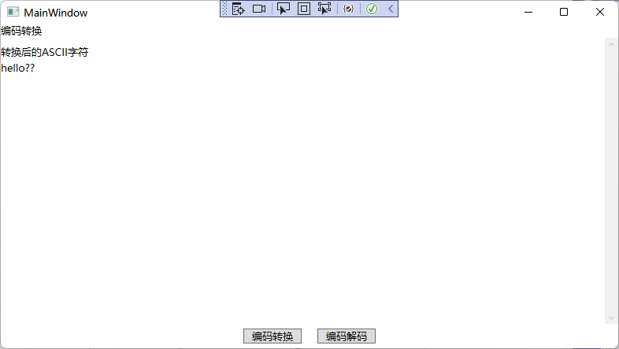

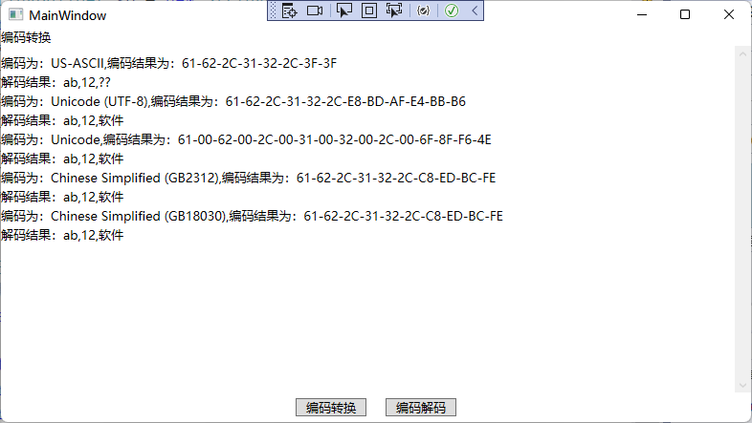

**4.3** **数据流**

**实验目的：**

使用FileStream类对数据流进行操作

**实验步骤：**

（1）在xaml文件中添加以下代码：

<DockPanel>

<Border DockPanel.Dock="Top">

<TextBlock Text="FileStream类的基本用法"/>

</Border>

<Border DockPanel.Dock="Bottom" >

<StackPanel Orientation="Horizontal" HorizontalAlignment="Center" VerticalAlignment="Center">

<Button Name="btnRead" Width="60" Content="读文件" Click="btnRead_Click"/>

<Button Name="btnWrite" Margin="10 0 0 0" Width="60" Content="写文件" Click="btnWrite_Click"/>

</StackPanel>

</Border>

<ScrollViewer>

<StackPanel Background="White" TextBlock.LineHeight="20">

<TextBlock x:Name="textBlock1" Margin="0 10 0 0" TextWrapping="Wrap"/>

</StackPanel>

</ScrollViewer>

</DockPanel>

（2）在mainWindow.xam.cs文件中主类public partial class MainWindow : Window下面添加以下代码：

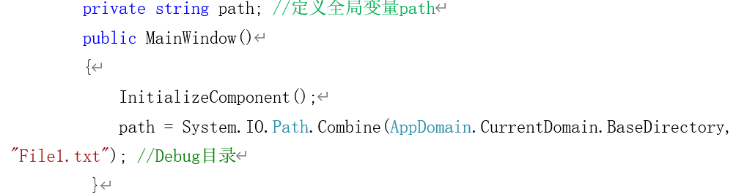

（3）添加按钮btnRead的click事件的实现代码：

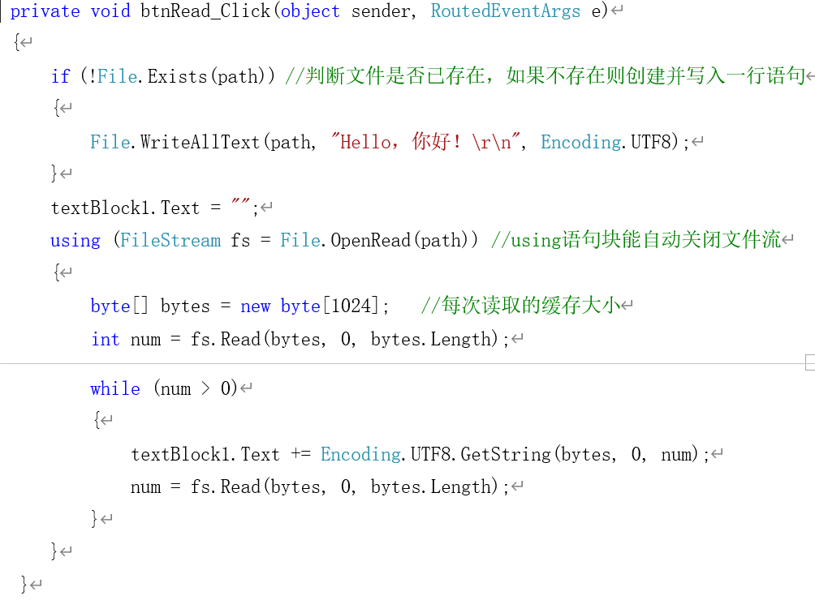

（4）添加按钮btnWrite的click事件的实现代码：

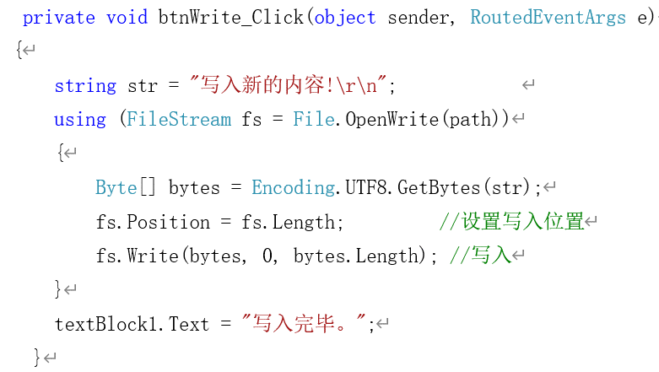

程序截图：

using System;

using System.Collections.Generic;

using System.IO;

using System.Linq;

using System.Text;

using System.Threading.Tasks;

using System.Windows;

using System.Windows.Controls;

using System.Windows.Data;

using System.Windows.Documents;

using System.Windows.Input;

using System.Windows.Media;

using System.Windows.Media.Imaging;

using System.Windows.Navigation;

using System.Windows.Shapes;

namespace sy4_3

{

/// <summary>

/// Interaction logic for MainWindow.xaml

/// </summary>

public partial class MainWindow : Window

{

private string path;

public MainWindow()

{

InitializeComponent();

path = System.IO.Path.Combine(AppDomain.CurrentDomain.BaseDirectory, "File1.txt");

}

private void btnRead_Click(object sender, RoutedEventArgs e)

{

if (!File.Exists(path))

{

File.WriteAllText(path,"Hello,你好！\r\n",Encoding.UTF8);

}

textBlock1.Text = "";

using (FileStream fs = File.OpenRead(path))

{

byte[] bytes = new byte[1024];

int num = fs.Read(bytes, 0, bytes.Length);

while (num>0)

{

textBlock1.Text += Encoding.UTF8.GetString(bytes, 0, num);

num = fs.Read(bytes, 0, bytes.Length);

}

}

}

private void btnWrite_Click(object sender, RoutedEventArgs e)

{

string str = "写入新的内容!\r\n";

using (FileStream fs = File.OpenWrite(path))

{

byte[] bytes = Encoding.UTF8.GetBytes(str);

fs.Position = fs.Length;

fs.Write(bytes,0,bytes.Length);

}

textBlock1.Text = "写入完毕";

}

}

}

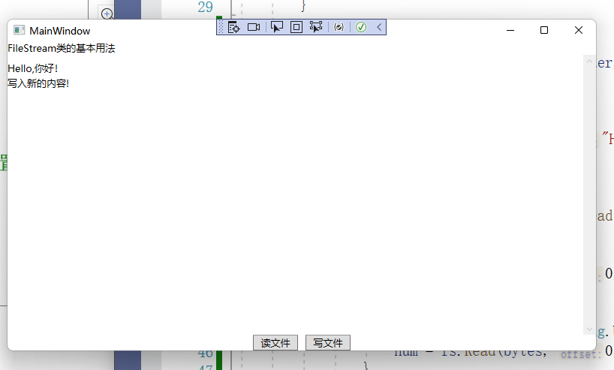

**4.4** **内存流**

**实验目的：**

使用MemoryStream类对数据流进行操作

**实验步骤：**

（1）在mainWindow.xaml中添加以下代码：

<DockPanel>

<Border DockPanel.Dock="Top">

<TextBlock Text="MemoryStream类的基本用法"/>

</Border>

<Border DockPanel.Dock="Bottom">

<StackPanel Orientation="Horizontal" HorizontalAlignment="Center" VerticalAlignment="Center">

<Button Name="btn1" Margin="10 5 10 5" Padding="10 0 10 0" Content="运行" Click="btn1_Click"/>

</StackPanel>

</Border>

<ScrollViewer>

<StackPanel Background="White" TextBlock.LineHeight="20">

<TextBlock x:Name="textBlock1" Margin="0 10 0 0" TextWrapping="Wrap"/>

</StackPanel>

</ScrollViewer>

</DockPanel>

（2）按钮btn1的click事件的实现代码：

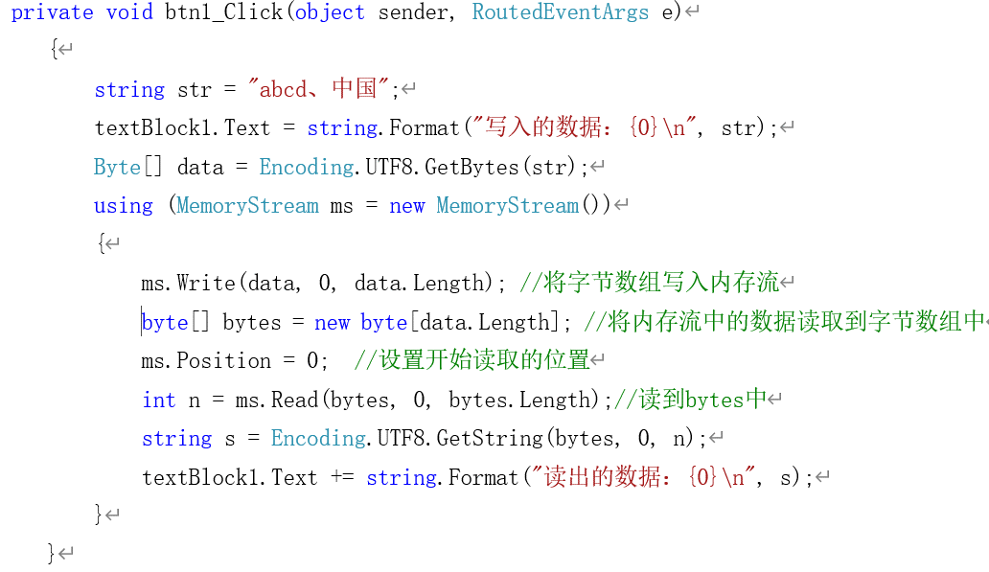

程序截图：

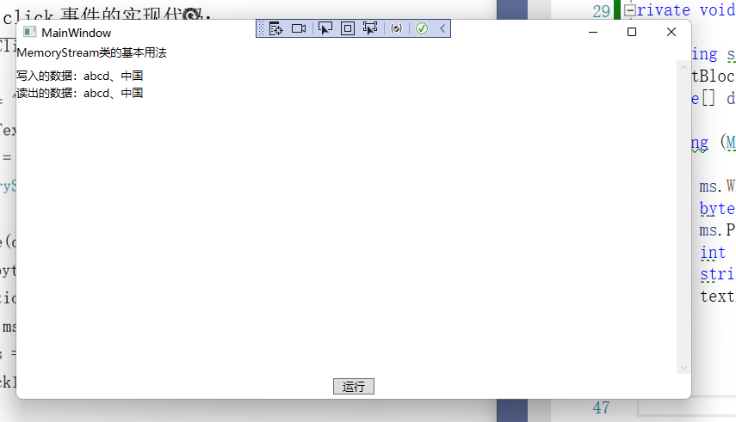

using System;

using System.Collections.Generic;

using System.IO;

using System.Linq;

using System.Text;

using System.Threading.Tasks;

using System.Windows;

using System.Windows.Controls;

using System.Windows.Data;

using System.Windows.Documents;

using System.Windows.Input;

using System.Windows.Media;

using System.Windows.Media.Imaging;

using System.Windows.Navigation;

using System.Windows.Shapes;

namespace sy4_4

{

/// <summary>

/// Interaction logic for MainWindow.xaml

/// </summary>

public partial class MainWindow : Window

{

public MainWindow()

{

InitializeComponent();

}

private void btn1_Click(object sender, RoutedEventArgs e)

{

string str = "abcd、中国";

textBlock1.Text = string.Format("写入的数据：{0}\n", str);

byte[] data = Encoding.UTF8.GetBytes(str);

using (MemoryStream ms = new MemoryStream())

{

ms.Write(data, 0, data.Length);

byte[] bytes = new byte[data.Length];

ms.Position = 0;

int n = ms.Read(bytes, 0, bytes.Length);

string s = Encoding.UTF8.GetString(bytes, 0, n);

textBlock1.Text += string.Format("读出的数据：{0}\n", s);

}

}

}

}